**National University of Sciences & Technology**

**School of Electrical Engineering and Computer Science**

**Department of Computing**

**CS867 Computer Vision**

|  |  |  |  |
| --- | --- | --- | --- |
| Assignment 1 | | | |
| Maximum Marks: | | Instructor: Dr. Muhammad Moazam Fraz | |
| Submission Date: 13/10/2021 | | Type: Code Report | |
| Name: Muhammad Ali | Reg. #: 329159 | Degree: MS DS F20 | Section: Fall 2020 |

# Task 1

## **SVM Classifier using HOG features**

Accuracy: 0.9684542586750788

precision recall f1-score support

neg 0.95 0.93 0.94 453

pos 0.97 0.98 0.98 1132

accuracy 0.97 1585

macro avg 0.96 0.96 0.96 1585

weighted avg 0.97 0.97 0.97 1585

True Positive are 1112

False Positive are 30

## **Random Forest Classifier using HOG features**

Accuracy: 0.9539432176656152

precision recall f1-score support

neg 0.96 0.88 0.92 453

pos 0.95 0.98 0.97 1132

accuracy 0.95 1585

macro avg 0.96 0.93 0.94 1585

weighted avg 0.95 0.95 0.95 1585

True Positive are 1115

False Positive are 56

## **SVM Classifier Pos Neg Examples**

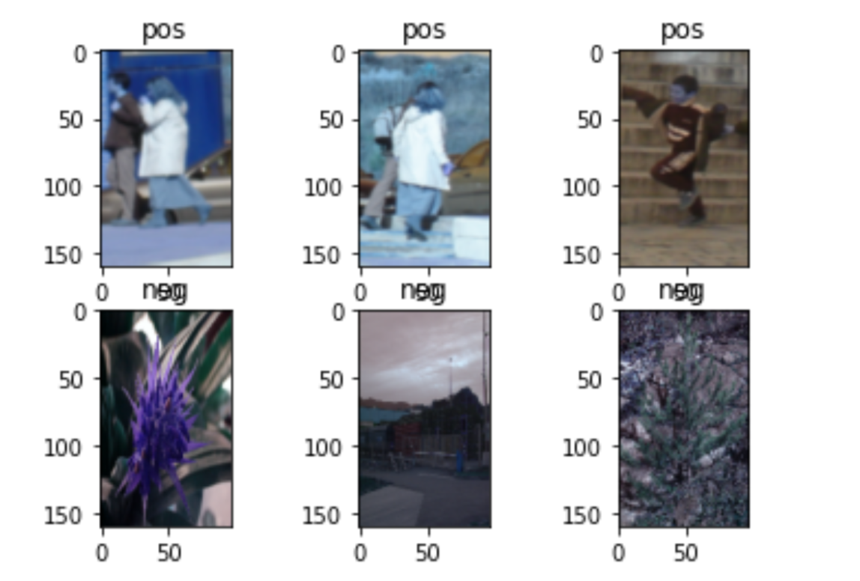

## **Random Forest Classifier Pos Neg Examples**

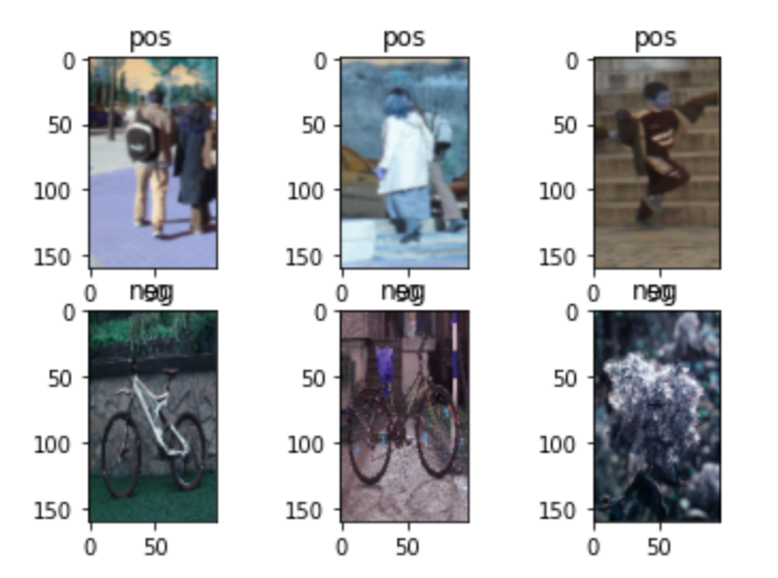

# Task 2

## **BoVW Objects Dataset Results**

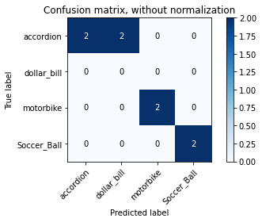

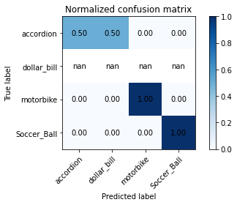

Confusion matrixes plotted.

accuracy score: 0.750

Accuracy calculated.

Execution done.

--- 1.6906065940856934 seconds ---

### **BoVW Objects Prediction Examples**

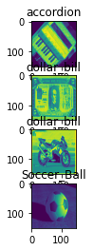

### **BoVW Flower Dataset Results**

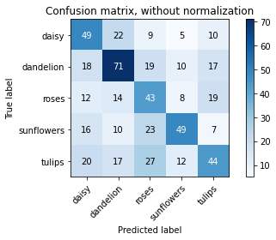

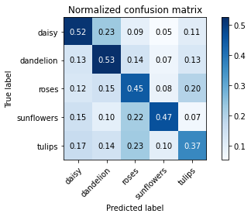

Confusion matrixes plotted.

accuracy score: 0.465

Accuracy calculated.

Execution done.

--- 181.15880513191223 seconds ---

### **BoVW Flower prediction example**

